Laporan Praktikum
Bahasa Pemrograman 1
Dosen pengampu : (Dede Husen, M.Kom.)

Modul 4



Nama : Muhammad Rizal Nurfirdaus
NIM : 20230810088
Kelas : TINFC – 2023 – 04

Teknik Informatika Fakultas Ilmu Komputer
Universitas Kuningan
PreTest
- Apa itu Swing Control?
Swing Control adalah komponen grafis (GUI) di Java yang disediakan oleh pustaka Swing untuk membangun antarmuka pengguna. Swing adalah bagian dari Java Foundation Classes (JFC) dan menawarkan kontrol seperti tombol, label, kotak teks, daftar, dan lainnya, yang dirancang untuk membuat antarmuka pengguna berbasis desktop yang interaktif.
- Apa fungsi dari Swing Control?
Swing Control memiliki beberapa fungsi utama, yaitu:
- Menyediakan Elemen GUI: Mengatur tampilan dan elemen interaktif seperti tombol, label, tabel, dan lainnya.
- Mempermudah Pengembangan GUI: Memungkinkan pengembang untuk membuat aplikasi desktop berbasis Java dengan antarmuka pengguna yang kaya.
- Portabilitas: Komponen Swing bersifat platform-independen sehingga tampilannya konsisten di berbagai sistem operasi.
- Event Handling: Mendukung pemrosesan interaksi pengguna, seperti klik tombol, entri teks, atau pemilihan item.

- Tuliskan contoh program sederhana untuk Swing control!
/*
* Click nbfs://nbhost/SystemFileSystem/Templates/Licenses/license-default.txt to change this license
* Click nbfs://nbhost/SystemFileSystem/Templates/GUIForms/JFrame.java to edit this template
*/
import javax.swing.*;
import java.awt.event.ActionEvent;
import java.awt.event.ActionListener;
/**
*
* @author Muhammad Rizal Nur F
*/

public class BP1_M4_PRETEST1_Rizal {
public static void main(String[] args) {
// Membuat JFrame
JFrame frame = new JFrame("Contoh Swing Control");
frame.setSize(400, 300); // Ukuran JFrame
frame.setDefaultCloseOperation(JFrame.EXIT_ON_CLOSE); // Menutup aplikasi saat JFrame ditutup
frame.setLayout(null); // Menggunakan layout null untuk posisi manual komponen

// Membuat Label
JLabel label = new JLabel("Nama:"); // Label untuk input nama
label.setBounds(50, 50, 100, 30); // Posisi dan ukuran label
frame.add(label);

// Membuat TextField
JTextField textField = new JTextField(); // Input teks untuk nama
textField.setBounds(150, 50, 150, 30); // Posisi dan ukuran TextField
frame.add(textField);

// Membuat Button
JButton button = new JButton("Tampilkan"); // Tombol untuk menampilkan nama
button.setBounds(150, 100, 100, 30); // Posisi dan ukuran tombol
frame.add(button);

// Membuat Label untuk output
JLabel outputLabel = new JLabel(); // Label untuk menampilkan hasil output
outputLabel.setBounds(50, 150, 300, 30); // Posisi dan ukuran output label
frame.add(outputLabel);

// Menambahkan Action Listener pada tombol
/*
* Click nbfs://nbhost/SystemFileSystem/Templates/Events/ActionListener.java to edit this template
*/
button.addActionListener(new ActionListener() {
@Override
public void actionPerformed(ActionEvent e) {
// Mengambil teks dari TextField
String nama = textField.getText();
// Menampilkan teks di outputLabel
outputLabel.setText("Halo, " + nama + "!");
}
});

// Menampilkan JFrame
frame.setVisible(true); // Membuat JFrame terlihat
}
}
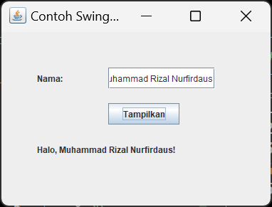
Praktikum

import javax.swing.JOptionPane;

/*
* Click nbfs://nbhost/SystemFileSystem/Templates/Licenses/license-default.txt to change this license
* Click nbfs://nbhost/SystemFileSystem/Templates/GUIForms/JFrame.java to edit this template
*/

/**
*
* @author Muhammad Rizal Nur F
*/
public class BP1_M4_P1_Rizal extends javax.swing.JFrame {

/**
* Creates new form BP1_M4_P1_Rizal
*/
public BP1_M4_P1_Rizal() {
initComponents();
}

private void Login() {
String user, pass;
user = jTextField1.getText();
pass = jTextField2.getText();

if(user.equals("admin")&&pass.equals("admin111"))
{
JOptionPane.showMessageDialog(null, "Login sukses sebagai " +user,
"Login Message",JOptionPane.INFORMATION_MESSAGE);
}
else
{
JOptionPane.showMessageDialog(null, "Login gagal", "Login message", JOptionPane.ERROR_MESSAGE);
}
}

/**
* This method is called from within the constructor to initialize the form.
* WARNING: Do NOT modify this code. The content of this method is always
* regenerated by the Form Editor.
*/
@SuppressWarnings("unchecked")
// <editor-fold defaultstate="collapsed" desc="Generated Code">
private void initComponents() {

jLabel1 = new javax.swing.JLabel();
jLabel2 = new javax.swing.JLabel();
jLabel3 = new javax.swing.JLabel();
jLabel4 = new javax.swing.JLabel();
jTextField1 = new javax.swing.JTextField();
jTextField2 = new javax.swing.JTextField();
jButton1 = new javax.swing.JButton();
jButton2 = new javax.swing.JButton();

setDefaultCloseOperation(javax.swing.WindowConstants.EXIT_ON_CLOSE);

jLabel1.setFont(new java.awt.Font("Segoe UI", 1, 12)); // NOI18N
jLabel1.setText("FORM LOGIN");

jLabel2.setIcon(new javax.swing.ImageIcon(getClass().getResource("/bayi.jpg"))); // NOI18N
jLabel2.setText("jLabel2");

jLabel3.setText("Username");

jLabel4.setText("Password");

jTextField1.addActionListener(new java.awt.event.ActionListener() {
public void actionPerformed(java.awt.event.ActionEvent evt) {
jTextField1ActionPerformed(evt);
}
});

jButton1.setText("LOGIN");
jButton1.addMouseListener(new java.awt.event.MouseAdapter() {
public void mouseClicked(java.awt.event.MouseEvent evt) {
jButton1MouseClicked(evt);
}
});
jButton1.addActionListener(new java.awt.event.ActionListener() {
public void actionPerformed(java.awt.event.ActionEvent evt) {
jButton1ActionPerformed(evt);
}
});

jButton2.setText("REGISTER");

javax.swing.GroupLayout layout = new javax.swing.GroupLayout(getContentPane());
getContentPane().setLayout(layout);
layout.setHorizontalGroup(
layout.createParallelGroup(javax.swing.GroupLayout.Alignment.LEADING)
.addGroup(layout.createSequentialGroup()
.addContainerGap()
.addComponent(jLabel2, javax.swing.GroupLayout.PREFERRED_SIZE, 177, javax.swing.GroupLayout.PREFERRED_SIZE)
.addGroup(layout.createParallelGroup(javax.swing.GroupLayout.Alignment.LEADING)
.addGroup(layout.createSequentialGroup()
.addPreferredGap(javax.swing.LayoutStyle.ComponentPlacement.RELATED)
.addGroup(layout.createParallelGroup(javax.swing.GroupLayout.Alignment.LEADING)
.addComponent(jLabel4)
.addGroup(layout.createSequentialGroup()
.addComponent(jLabel3)
.addGap(64, 64, 64)
.addGroup(layout.createParallelGroup(javax.swing.GroupLayout.Alignment.LEADING)
.addComponent(jTextField2, javax.swing.GroupLayout.PREFERRED_SIZE, 71, javax.swing.GroupLayout.PREFERRED_SIZE)
.addComponent(jTextField1, javax.swing.GroupLayout.PREFERRED_SIZE, 71, javax.swing.GroupLayout.PREFERRED_SIZE)))))
.addGroup(layout.createSequentialGroup()
.addGap(40, 40, 40)
.addGroup(layout.createParallelGroup(javax.swing.GroupLayout.Alignment.TRAILING)
.addComponent(jButton1)
.addComponent(jLabel1))
.addGap(18, 18, 18)
.addComponent(jButton2)))
.addContainerGap(29, Short.MAX_VALUE))
);
layout.setVerticalGroup(
layout.createParallelGroup(javax.swing.GroupLayout.Alignment.LEADING)
.addGroup(layout.createSequentialGroup()
.addGap(64, 64, 64)
.addGroup(layout.createParallelGroup(javax.swing.GroupLayout.Alignment.LEADING)
.addComponent(jLabel2, javax.swing.GroupLayout.PREFERRED_SIZE, 188, javax.swing.GroupLayout.PREFERRED_SIZE)
.addGroup(layout.createSequentialGroup()
.addComponent(jLabel1)
.addGap(33, 33, 33)
.addGroup(layout.createParallelGroup(javax.swing.GroupLayout.Alignment.BASELINE)
.addComponent(jLabel3)
.addComponent(jTextField1, javax.swing.GroupLayout.PREFERRED_SIZE, javax.swing.GroupLayout.DEFAULT_SIZE, javax.swing.GroupLayout.PREFERRED_SIZE))
.addGap(45, 45, 45)
.addGroup(layout.createParallelGroup(javax.swing.GroupLayout.Alignment.BASELINE)
.addComponent(jLabel4)
.addComponent(jTextField2, javax.swing.GroupLayout.PREFERRED_SIZE, javax.swing.GroupLayout.DEFAULT_SIZE, javax.swing.GroupLayout.PREFERRED_SIZE))
.addGap(46, 46, 46)
.addGroup(layout.createParallelGroup(javax.swing.GroupLayout.Alignment.BASELINE)
.addComponent(jButton1)
.addComponent(jButton2))))
.addContainerGap(390, Short.MAX_VALUE))
);

pack();
}// </editor-fold>

private void jTextField1ActionPerformed(java.awt.event.ActionEvent evt) {
// TODO add your handling code here:
}

private void jButton1MouseClicked(java.awt.event.MouseEvent evt) {
// TODO add your handling code here:
}

private void jButton1ActionPerformed(java.awt.event.ActionEvent evt) {
// TODO add your handling code here:
Login();
}

/**
* @param args the command line arguments
*/
public static void main(String args[]) {
/* Set the Nimbus look and feel */
//<editor-fold defaultstate="collapsed" desc=" Look and feel setting code (optional) ">
/* If Nimbus (introduced in Java SE 6) is not available, stay with the default look and feel.
* For details see http://download.oracle.com/javase/tutorial/uiswing/lookandfeel/plaf.html
*/
try {
for (javax.swing.UIManager.LookAndFeelInfo info : javax.swing.UIManager.getInstalledLookAndFeels()) {
if ("Nimbus".equals(info.getName())) {
javax.swing.UIManager.setLookAndFeel(info.getClassName());
break;
}
}
} catch (ClassNotFoundException ex) {
java.util.logging.Logger.getLogger(BP1_M4_P1_Rizal.class.getName()).log(java.util.logging.Level.SEVERE, null, ex);
} catch (InstantiationException ex) {
java.util.logging.Logger.getLogger(BP1_M4_P1_Rizal.class.getName()).log(java.util.logging.Level.SEVERE, null, ex);
} catch (IllegalAccessException ex) {
java.util.logging.Logger.getLogger(BP1_M4_P1_Rizal.class.getName()).log(java.util.logging.Level.SEVERE, null, ex);
} catch (javax.swing.UnsupportedLookAndFeelException ex) {
java.util.logging.Logger.getLogger(BP1_M4_P1_Rizal.class.getName()).log(java.util.logging.Level.SEVERE, null, ex);
}
//</editor-fold>

/* Create and display the form */
java.awt.EventQueue.invokeLater(new Runnable() {
public void run() {
new BP1_M4_P1_Rizal().setVisible(true);
}
});
}

// Variables declaration - do not modify
private javax.swing.JButton jButton1;
private javax.swing.JButton jButton2;
private javax.swing.JLabel jLabel1;
private javax.swing.JLabel jLabel2;
private javax.swing.JLabel jLabel3;
private javax.swing.JLabel jLabel4;
private javax.swing.JTextField jTextField1;
private javax.swing.JTextField jTextField2;
// End of variables declaration
}
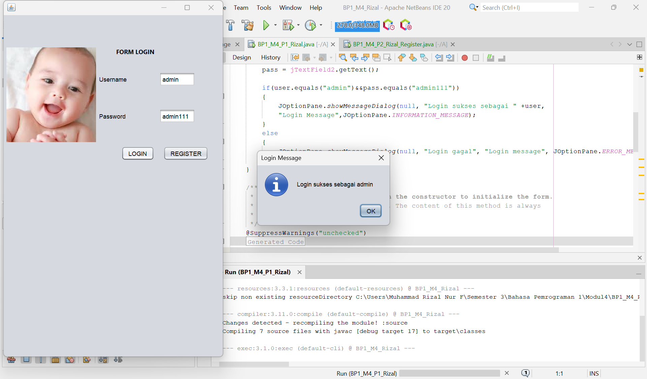
Analisis : Kode di atas adalah implementasi sederhana dari aplikasi Form Login menggunakan Java Swing. Aplikasi ini memiliki antarmuka grafis dengan dua bidang teks untuk input username dan password, serta dua tombol: "LOGIN" dan "REGISTER". Saat tombol "LOGIN" diklik, metode Login() akan dipanggil untuk memeriksa apakah username dan password yang dimasukkan sesuai dengan nilai tetap ("admin" dan "admin111"). Jika cocok, pesan sukses akan ditampilkan menggunakan JOptionPane, sementara jika tidak, pesan kesalahan akan muncul. Desain antarmuka mencakup label, teks, dan ikon, yang diatur menggunakan javax.swing.GroupLayout.

/*
* Click nbfs://nbhost/SystemFileSystem/Templates/Licenses/license-default.txt to change this license
* Click nbfs://nbhost/SystemFileSystem/Templates/GUIForms/JFrame.java to edit this template
*/

/**
*
* @author Muhammad Rizal Nur F
*/
public class BP1_M4_P2_Rizal_Register extends javax.swing.JFrame {

/**
* Creates new form BP1_M4_P2_Rizal_Register
*/
public BP1_M4_P2_Rizal_Register() {
initComponents();
}
private void simpan()
{
String nim, nama, jk, prodi, alamat;
nim=jTextField1.getText(); nama=jTextField2.getText();
//Jenis Kelamin
jk="";
if(buttonGroup1.isSelected (null))
{
jk=jRadioButton1.getText();
}

else {jk=jRadioButton2.getText(); }

prodi=(String) jComboBox1.getSelectedItem();

//HOBI
StringBuffer hobi = new StringBuffer();
if(jCheckBox1.isSelected())
{hobi.append(jCheckBox1.getText() + ",");}
if(jCheckBox2.isSelected())
{hobi.append(jCheckBox2.getText() + ",");}
if(jCheckBox3.isSelected())
{hobi.append(jCheckBox3.getText() + ",");}
else
{hobi.append(jCheckBox4.getText() + ",");}

alamat=jTextArea1.getText();
jTextArea2.setText("DATA REGISTER \n"
+ "1. NIM : "+nim+"\n"
+ "2. NAMA : "+nama+"\n"
+ "3. Jenis Kelamin : "+jk+"\n"
+ "4. Prodi : "+prodi+"\n"
+ "5. Hobi : "+hobi+"\n"
+ "6. Alamat : "+alamat+"\n");

}

/**
* This method is called from within the constructor to initialize the form.
* WARNING: Do NOT modify this code. The content of this method is always
* regenerated by the Form Editor.
*/
@SuppressWarnings("unchecked")
// <editor-fold defaultstate="collapsed" desc="Generated Code">
private void initComponents() {

buttonGroup1 = new javax.swing.ButtonGroup();
jLabel1 = new javax.swing.JLabel();
jLabel2 = new javax.swing.JLabel();
jLabel3 = new javax.swing.JLabel();
jLabel4 = new javax.swing.JLabel();
jTextField1 = new javax.swing.JTextField();
jRadioButton1 = new javax.swing.JRadioButton();
jRadioButton2 = new javax.swing.JRadioButton();
jComboBox1 = new javax.swing.JComboBox<>();
jLabel5 = new javax.swing.JLabel();
jCheckBox1 = new javax.swing.JCheckBox();
jCheckBox2 = new javax.swing.JCheckBox();
jCheckBox3 = new javax.swing.JCheckBox();
jCheckBox4 = new javax.swing.JCheckBox();
jLabel6 = new javax.swing.JLabel();
jTextField2 = new javax.swing.JTextField();
jButton1 = new javax.swing.JButton();
jLabel7 = new javax.swing.JLabel();
jScrollPane1 = new javax.swing.JScrollPane();
jTextArea1 = new javax.swing.JTextArea();
jScrollPane2 = new javax.swing.JScrollPane();
jTextArea2 = new javax.swing.JTextArea();

setDefaultCloseOperation(javax.swing.WindowConstants.EXIT_ON_CLOSE);

jLabel1.setFont(new java.awt.Font("Segoe UI", 1, 12)); // NOI18N
jLabel1.setText("FORM REGISTER");

jLabel2.setText("NIM");

jLabel3.setText("NAMA");

jLabel4.setText("JENIS KELAMIN");

jRadioButton1.setText("Laki-laki");

jRadioButton2.setText("Perempuan");

jComboBox1.setModel(new javax.swing.DefaultComboBoxModel<>(new String[] { "Teknik Informatika", "Sistem Informasi", "Desain Komunikasi Visual", "Manejemen Informatika" }));
jComboBox1.addActionListener(new java.awt.event.ActionListener() {
public void actionPerformed(java.awt.event.ActionEvent evt) {
jComboBox1ActionPerformed(evt);
}
});

jLabel5.setText("PRODI");

jCheckBox1.setText("NONTON");

jCheckBox2.setText("OLAHRAGA");

jCheckBox3.setText("DENGERIN MUSIK");

jCheckBox4.setText("TRAVELING");

jLabel6.setText("HOBI");

jTextField2.addActionListener(new java.awt.event.ActionListener() {
public void actionPerformed(java.awt.event.ActionEvent evt) {
jTextField2ActionPerformed(evt);
}
});

jButton1.setText("REGISTER");
jButton1.addMouseListener(new java.awt.event.MouseAdapter() {
public void mouseClicked(java.awt.event.MouseEvent evt) {
jButton1MouseClicked(evt);
}
});
jButton1.addActionListener(new java.awt.event.ActionListener() {
public void actionPerformed(java.awt.event.ActionEvent evt) {
jButton1ActionPerformed(evt);
}
});

jLabel7.setText("ALAMAT");

jTextArea1.setColumns(20);
jTextArea1.setRows(5);
jScrollPane1.setViewportView(jTextArea1);

jTextArea2.setColumns(20);
jTextArea2.setRows(5);
jScrollPane2.setViewportView(jTextArea2);

javax.swing.GroupLayout layout = new javax.swing.GroupLayout(getContentPane());
getContentPane().setLayout(layout);
layout.setHorizontalGroup(
layout.createParallelGroup(javax.swing.GroupLayout.Alignment.LEADING)
.addGroup(layout.createSequentialGroup()
.addGroup(layout.createParallelGroup(javax.swing.GroupLayout.Alignment.LEADING)
.addGroup(layout.createSequentialGroup()
.addGap(159, 159, 159)
.addComponent(jLabel1))
.addGroup(layout.createSequentialGroup()
.addContainerGap()
.addGroup(layout.createParallelGroup(javax.swing.GroupLayout.Alignment.LEADING)
.addComponent(jLabel2)
.addComponent(jLabel3)
.addComponent(jLabel4)
.addComponent(jLabel5)
.addComponent(jLabel6)
.addComponent(jLabel7))
.addGap(67, 67, 67)
.addGroup(layout.createParallelGroup(javax.swing.GroupLayout.Alignment.LEADING, false)
.addComponent(jTextField2)
.addComponent(jTextField1)
.addGroup(layout.createSequentialGroup()
.addGroup(layout.createParallelGroup(javax.swing.GroupLayout.Alignment.LEADING)
.addComponent(jRadioButton1)
.addComponent(jCheckBox1, javax.swing.GroupLayout.PREFERRED_SIZE, 85, javax.swing.GroupLayout.PREFERRED_SIZE))
.addPreferredGap(javax.swing.LayoutStyle.ComponentPlacement.RELATED, 108, Short.MAX_VALUE)
.addComponent(jRadioButton2)
.addGap(45, 45, 45))
.addGroup(layout.createSequentialGroup()
.addComponent(jCheckBox2)
.addGap(32, 32, 32)
.addGroup(layout.createParallelGroup(javax.swing.GroupLayout.Alignment.LEADING)
.addComponent(jCheckBox4, javax.swing.GroupLayout.PREFERRED_SIZE, 85, javax.swing.GroupLayout.PREFERRED_SIZE)
.addComponent(jCheckBox3, javax.swing.GroupLayout.PREFERRED_SIZE, 127, javax.swing.GroupLayout.PREFERRED_SIZE)))
.addComponent(jComboBox1, javax.swing.GroupLayout.PREFERRED_SIZE, 152, javax.swing.GroupLayout.PREFERRED_SIZE)
.addComponent(jButton1)
.addComponent(jScrollPane1, javax.swing.GroupLayout.PREFERRED_SIZE, javax.swing.GroupLayout.DEFAULT_SIZE, javax.swing.GroupLayout.PREFERRED_SIZE)))
.addGroup(javax.swing.GroupLayout.Alignment.TRAILING, layout.createSequentialGroup()
.addContainerGap()
.addComponent(jScrollPane2, javax.swing.GroupLayout.PREFERRED_SIZE, 352, javax.swing.GroupLayout.PREFERRED_SIZE)
.addGap(87, 87, 87)))
.addContainerGap(javax.swing.GroupLayout.DEFAULT_SIZE, Short.MAX_VALUE))
);
layout.setVerticalGroup(
layout.createParallelGroup(javax.swing.GroupLayout.Alignment.LEADING)
.addGroup(layout.createSequentialGroup()
.addContainerGap()
.addComponent(jLabel1)
.addPreferredGap(javax.swing.LayoutStyle.ComponentPlacement.RELATED)
.addGroup(layout.createParallelGroup(javax.swing.GroupLayout.Alignment.LEADING)
.addComponent(jLabel2)
.addComponent(jTextField1, javax.swing.GroupLayout.PREFERRED_SIZE, javax.swing.GroupLayout.DEFAULT_SIZE, javax.swing.GroupLayout.PREFERRED_SIZE))
.addPreferredGap(javax.swing.LayoutStyle.ComponentPlacement.RELATED)
.addGroup(layout.createParallelGroup(javax.swing.GroupLayout.Alignment.BASELINE)
.addComponent(jLabel3)
.addComponent(jTextField2, javax.swing.GroupLayout.PREFERRED_SIZE, javax.swing.GroupLayout.DEFAULT_SIZE, javax.swing.GroupLayout.PREFERRED_SIZE))
.addGap(14, 14, 14)
.addGroup(layout.createParallelGroup(javax.swing.GroupLayout.Alignment.BASELINE)
.addComponent(jLabel4)
.addComponent(jRadioButton1)
.addComponent(jRadioButton2))
.addGap(8, 8, 8)
.addGroup(layout.createParallelGroup(javax.swing.GroupLayout.Alignment.BASELINE)
.addComponent(jComboBox1, javax.swing.GroupLayout.PREFERRED_SIZE, javax.swing.GroupLayout.DEFAULT_SIZE, javax.swing.GroupLayout.PREFERRED_SIZE)
.addComponent(jLabel5))
.addPreferredGap(javax.swing.LayoutStyle.ComponentPlacement.RELATED)
.addGroup(layout.createParallelGroup(javax.swing.GroupLayout.Alignment.BASELINE)
.addComponent(jCheckBox1)
.addComponent(jCheckBox3)
.addComponent(jLabel6))
.addPreferredGap(javax.swing.LayoutStyle.ComponentPlacement.UNRELATED)
.addGroup(layout.createParallelGroup(javax.swing.GroupLayout.Alignment.BASELINE)
.addComponent(jCheckBox2)
.addComponent(jCheckBox4))
.addPreferredGap(javax.swing.LayoutStyle.ComponentPlacement.RELATED)
.addGroup(layout.createParallelGroup(javax.swing.GroupLayout.Alignment.LEADING)
.addComponent(jLabel7)
.addComponent(jScrollPane1, javax.swing.GroupLayout.PREFERRED_SIZE, javax.swing.GroupLayout.DEFAULT_SIZE, javax.swing.GroupLayout.PREFERRED_SIZE))
.addPreferredGap(javax.swing.LayoutStyle.ComponentPlacement.RELATED)
.addComponent(jButton1)
.addPreferredGap(javax.swing.LayoutStyle.ComponentPlacement.RELATED)
.addComponent(jScrollPane2, javax.swing.GroupLayout.DEFAULT_SIZE, 95, Short.MAX_VALUE)
.addContainerGap())
);

pack();
}// </editor-fold>

private void jTextField2ActionPerformed(java.awt.event.ActionEvent evt) {
// TODO add your handling code here:
}

private void jComboBox1ActionPerformed(java.awt.event.ActionEvent evt) {
// TODO add your handling code here:
}

private void jButton1MouseClicked(java.awt.event.MouseEvent evt) {
// TODO add your handling code here:
}

private void jButton1ActionPerformed(java.awt.event.ActionEvent evt) {
// TODO add your handling code here:
simpan();
}

/**
* @param args the command line arguments
*/
public static void main(String args[]) {
/* Set the Nimbus look and feel */
//<editor-fold defaultstate="collapsed" desc=" Look and feel setting code (optional) ">
/* If Nimbus (introduced in Java SE 6) is not available, stay with the default look and feel.
* For details see http://download.oracle.com/javase/tutorial/uiswing/lookandfeel/plaf.html
*/
try {
for (javax.swing.UIManager.LookAndFeelInfo info : javax.swing.UIManager.getInstalledLookAndFeels()) {
if ("Nimbus".equals(info.getName())) {
javax.swing.UIManager.setLookAndFeel(info.getClassName());
break;
}
}
} catch (ClassNotFoundException ex) {
java.util.logging.Logger.getLogger(BP1_M4_P2_Rizal_Register.class.getName()).log(java.util.logging.Level.SEVERE, null, ex);
} catch (InstantiationException ex) {
java.util.logging.Logger.getLogger(BP1_M4_P2_Rizal_Register.class.getName()).log(java.util.logging.Level.SEVERE, null, ex);
} catch (IllegalAccessException ex) {
java.util.logging.Logger.getLogger(BP1_M4_P2_Rizal_Register.class.getName()).log(java.util.logging.Level.SEVERE, null, ex);
} catch (javax.swing.UnsupportedLookAndFeelException ex) {
java.util.logging.Logger.getLogger(BP1_M4_P2_Rizal_Register.class.getName()).log(java.util.logging.Level.SEVERE, null, ex);
}
//</editor-fold>

/* Create and display the form */
java.awt.EventQueue.invokeLater(new Runnable() {
public void run() {
new BP1_M4_P2_Rizal_Register().setVisible(true);
}
});
}

// Variables declaration - do not modify
private javax.swing.ButtonGroup buttonGroup1;
private javax.swing.JButton jButton1;
private javax.swing.JCheckBox jCheckBox1;
private javax.swing.JCheckBox jCheckBox2;
private javax.swing.JCheckBox jCheckBox3;
private javax.swing.JCheckBox jCheckBox4;
private javax.swing.JComboBox<String> jComboBox1;
private javax.swing.JLabel jLabel1;
private javax.swing.JLabel jLabel2;
private javax.swing.JLabel jLabel3;
private javax.swing.JLabel jLabel4;
private javax.swing.JLabel jLabel5;
private javax.swing.JLabel jLabel6;
private javax.swing.JLabel jLabel7;
private javax.swing.JRadioButton jRadioButton1;
private javax.swing.JRadioButton jRadioButton2;
private javax.swing.JScrollPane jScrollPane1;
private javax.swing.JScrollPane jScrollPane2;
private javax.swing.JTextArea jTextArea1;
private javax.swing.JTextArea jTextArea2;
private javax.swing.JTextField jTextField1;
private javax.swing.JTextField jTextField2;
// End of variables declaration
}
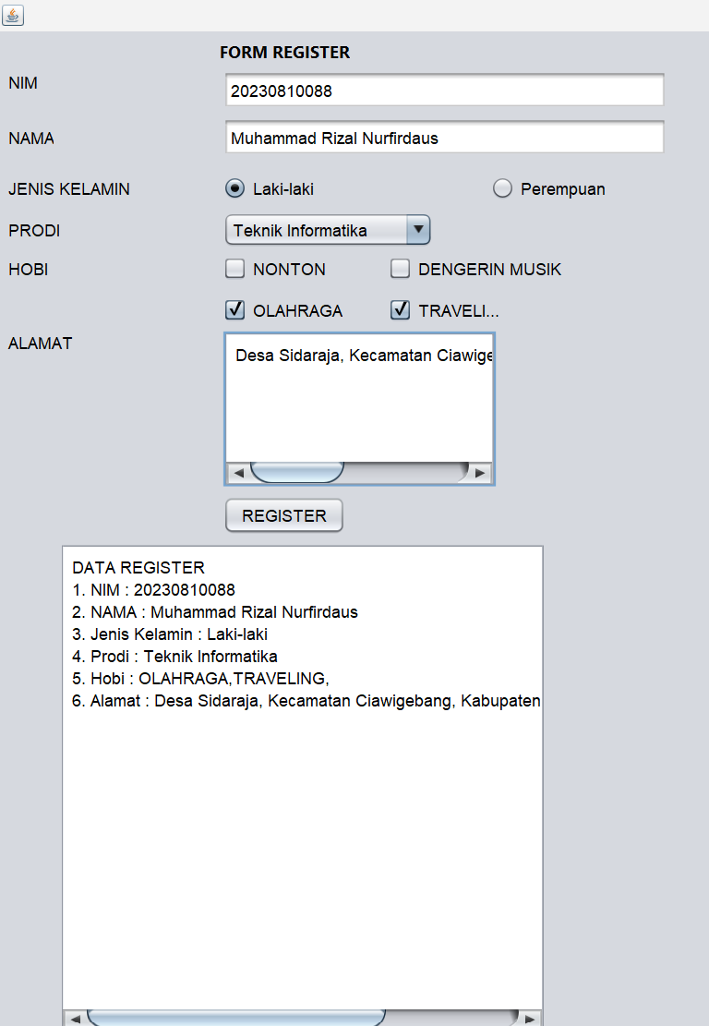
Analisis : Program ini adalah sebuah aplikasi berbasis GUI (Graphical User Interface) yang menggunakan Java Swing untuk membuat formulir pendaftaran. Pengguna diminta untuk mengisi beberapa informasi seperti NIM, nama, jenis kelamin, program studi, hobi, dan alamat. Data yang dimasukkan akan ditampilkan kembali di area teks setelah pengguna menekan tombol "REGISTER". Program ini menggunakan berbagai komponen Swing, termasuk JTextField, JRadioButton, JComboBox, JCheckBox, dan JTextArea untuk menangani input dan menampilkan data.
PostTest
- Lengkapi kondisi Login, sehingga memiliki kondisi:
- Jika username tidak diisi, maka akan menampilkan message "username harus diisi".
- Jika username salah, maka akan menampilkan message "username salah".
- Jika password tidak diisi, maka akan menampilkan message "password harus diisi".
- Jika password salah, maka akan menampilkan message "password salah".

import javax.swing.JOptionPane;

/*
* Click nbfs://nbhost/SystemFileSystem/Templates/Licenses/license-default.txt to change this license
* Click nbfs://nbhost/SystemFileSystem/Templates/GUIForms/JFrame.java to edit this template
*/

/**
*
* @author Muhammad Rizal Nur F
*/
public class BP1_M4_P1_Rizal extends javax.swing.JFrame {

/**
* Creates new form BP1_M4_P1_Rizal
*/
public BP1_M4_P1_Rizal() {
initComponents();
}

private void Login() {
String user, pass;
user = jTextField1.getText();
pass = jTextField2.getText();

// Validasi untuk username tidak diisi
if (user.isEmpty()) {
JOptionPane.showMessageDialog(null, "Username harus diisi", "Login Message", JOptionPane.WARNING_MESSAGE);
return;
}

// Validasi untuk password tidak diisi
if (pass.isEmpty()) {
JOptionPane.showMessageDialog(null, "Password harus diisi", "Login Message", JOptionPane.WARNING_MESSAGE);
return;
}

// Validasi untuk username salah
if (!user.equals("admin")) {
JOptionPane.showMessageDialog(null, "Username salah", "Login Message", JOptionPane.ERROR_MESSAGE);
return;
}

// Validasi untuk password salah
if (!pass.equals("admin111")) {
JOptionPane.showMessageDialog(null, "Password salah", "Login Message", JOptionPane.ERROR_MESSAGE);
return;
}

// Jika semua validasi lolos
JOptionPane.showMessageDialog(null, "Login sukses sebagai " + user, "Login Message", JOptionPane.INFORMATION_MESSAGE);
}

/**
* This method is called from within the constructor to initialize the form.
* WARNING: Do NOT modify this code. The content of this method is always
* regenerated by the Form Editor.
*/
@SuppressWarnings("unchecked")
// <editor-fold defaultstate="collapsed" desc="Generated Code">
private void initComponents() {

jLabel1 = new javax.swing.JLabel();
jLabel2 = new javax.swing.JLabel();
jLabel3 = new javax.swing.JLabel();
jLabel4 = new javax.swing.JLabel();
jTextField1 = new javax.swing.JTextField();
jTextField2 = new javax.swing.JTextField();
jButton1 = new javax.swing.JButton();
jButton2 = new javax.swing.JButton();

setDefaultCloseOperation(javax.swing.WindowConstants.EXIT_ON_CLOSE);

jLabel1.setFont(new java.awt.Font("Segoe UI", 1, 12)); // NOI18N
jLabel1.setText("FORM LOGIN");

jLabel2.setIcon(new javax.swing.ImageIcon(getClass().getResource("/bayi.jpg"))); // NOI18N
jLabel2.setText("jLabel2");

jLabel3.setText("Username");

jLabel4.setText("Password");

jTextField1.addActionListener(new java.awt.event.ActionListener() {
public void actionPerformed(java.awt.event.ActionEvent evt) {
jTextField1ActionPerformed(evt);
}
});

jButton1.setText("LOGIN");
jButton1.addMouseListener(new java.awt.event.MouseAdapter() {
public void mouseClicked(java.awt.event.MouseEvent evt) {
jButton1MouseClicked(evt);
}
});
jButton1.addActionListener(new java.awt.event.ActionListener() {
public void actionPerformed(java.awt.event.ActionEvent evt) {
jButton1ActionPerformed(evt);
}
});

jButton2.setText("REGISTER");

javax.swing.GroupLayout layout = new javax.swing.GroupLayout(getContentPane());
getContentPane().setLayout(layout);
layout.setHorizontalGroup(
layout.createParallelGroup(javax.swing.GroupLayout.Alignment.LEADING)
.addGroup(layout.createSequentialGroup()
.addContainerGap()
.addComponent(jLabel2, javax.swing.GroupLayout.PREFERRED_SIZE, 177, javax.swing.GroupLayout.PREFERRED_SIZE)
.addGroup(layout.createParallelGroup(javax.swing.GroupLayout.Alignment.LEADING)
.addGroup(layout.createSequentialGroup()
.addPreferredGap(javax.swing.LayoutStyle.ComponentPlacement.RELATED)
.addGroup(layout.createParallelGroup(javax.swing.GroupLayout.Alignment.LEADING)
.addComponent(jLabel4)
.addGroup(layout.createSequentialGroup()
.addComponent(jLabel3)
.addGap(64, 64, 64)
.addGroup(layout.createParallelGroup(javax.swing.GroupLayout.Alignment.LEADING)
.addComponent(jTextField2, javax.swing.GroupLayout.PREFERRED_SIZE, 71, javax.swing.GroupLayout.PREFERRED_SIZE)
.addComponent(jTextField1, javax.swing.GroupLayout.PREFERRED_SIZE, 71, javax.swing.GroupLayout.PREFERRED_SIZE)))))
.addGroup(layout.createSequentialGroup()
.addGap(40, 40, 40)
.addGroup(layout.createParallelGroup(javax.swing.GroupLayout.Alignment.TRAILING)
.addComponent(jButton1)
.addComponent(jLabel1))
.addGap(18, 18, 18)
.addComponent(jButton2)))
.addContainerGap(29, Short.MAX_VALUE))
);
layout.setVerticalGroup(
layout.createParallelGroup(javax.swing.GroupLayout.Alignment.LEADING)
.addGroup(layout.createSequentialGroup()
.addGap(64, 64, 64)
.addGroup(layout.createParallelGroup(javax.swing.GroupLayout.Alignment.LEADING)
.addComponent(jLabel2, javax.swing.GroupLayout.PREFERRED_SIZE, 188, javax.swing.GroupLayout.PREFERRED_SIZE)
.addGroup(layout.createSequentialGroup()
.addComponent(jLabel1)
.addGap(33, 33, 33)
.addGroup(layout.createParallelGroup(javax.swing.GroupLayout.Alignment.BASELINE)
.addComponent(jLabel3)
.addComponent(jTextField1, javax.swing.GroupLayout.PREFERRED_SIZE, javax.swing.GroupLayout.DEFAULT_SIZE, javax.swing.GroupLayout.PREFERRED_SIZE))
.addGap(45, 45, 45)
.addGroup(layout.createParallelGroup(javax.swing.GroupLayout.Alignment.BASELINE)
.addComponent(jLabel4)
.addComponent(jTextField2, javax.swing.GroupLayout.PREFERRED_SIZE, javax.swing.GroupLayout.DEFAULT_SIZE, javax.swing.GroupLayout.PREFERRED_SIZE))
.addGap(46, 46, 46)
.addGroup(layout.createParallelGroup(javax.swing.GroupLayout.Alignment.BASELINE)
.addComponent(jButton1)
.addComponent(jButton2))))
.addContainerGap(390, Short.MAX_VALUE))
);

pack();
}// </editor-fold>

private void jTextField1ActionPerformed(java.awt.event.ActionEvent evt) {
// TODO add your handling code here:
}

private void jButton1MouseClicked(java.awt.event.MouseEvent evt) {
// TODO add your handling code here:
}

private void jButton1ActionPerformed(java.awt.event.ActionEvent evt) {
// TODO add your handling code here:
Login();
}

/**
* @param args the command line arguments
*/
public static void main(String args[]) {
/* Set the Nimbus look and feel */
//<editor-fold defaultstate="collapsed" desc=" Look and feel setting code (optional) ">
/* If Nimbus (introduced in Java SE 6) is not available, stay with the default look and feel.
* For details see http://download.oracle.com/javase/tutorial/uiswing/lookandfeel/plaf.html
*/
try {
for (javax.swing.UIManager.LookAndFeelInfo info : javax.swing.UIManager.getInstalledLookAndFeels()) {
if ("Nimbus".equals(info.getName())) {
javax.swing.UIManager.setLookAndFeel(info.getClassName());
break;
}
}
} catch (ClassNotFoundException ex) {
java.util.logging.Logger.getLogger(BP1_M4_P1_Rizal.class.getName()).log(java.util.logging.Level.SEVERE, null, ex);
} catch (InstantiationException ex) {
java.util.logging.Logger.getLogger(BP1_M4_P1_Rizal.class.getName()).log(java.util.logging.Level.SEVERE, null, ex);
} catch (IllegalAccessException ex) {
java.util.logging.Logger.getLogger(BP1_M4_P1_Rizal.class.getName()).log(java.util.logging.Level.SEVERE, null, ex);
} catch (javax.swing.UnsupportedLookAndFeelException ex) {
java.util.logging.Logger.getLogger(BP1_M4_P1_Rizal.class.getName()).log(java.util.logging.Level.SEVERE, null, ex);
}
//</editor-fold>

/* Create and display the form */
java.awt.EventQueue.invokeLater(new Runnable() {
public void run() {
new BP1_M4_P1_Rizal().setVisible(true);
}
});
}

// Variables declaration - do not modify
private javax.swing.JButton jButton1;
private javax.swing.JButton jButton2;
private javax.swing.JLabel jLabel1;
private javax.swing.JLabel jLabel2;
private javax.swing.JLabel jLabel3;
private javax.swing.JLabel jLabel4;
private javax.swing.JTextField jTextField1;
private javax.swing.JTextField jTextField2;
// End of variables declaration
}
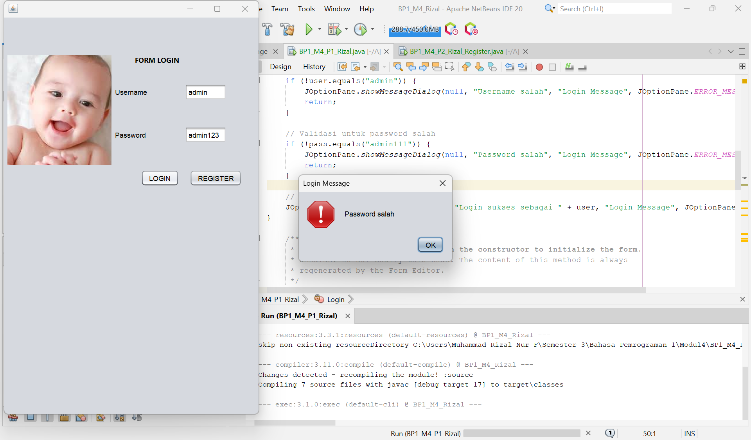
Analisis :
- Cek Username Kosong: Menambahkan validasi untuk mengecek apakah jTextField1 (username) kosong. Jika kosong, akan muncul pesan "Username harus diisi".
- Cek Password Kosong: Menambahkan validasi untuk mengecek apakah jTextField2 (password) kosong. Jika kosong, akan muncul pesan "Password harus diisi".
- Cek Username Salah: Menambahkan validasi untuk mengecek apakah username yang dimasukkan bukan "admin". Jika salah, akan muncul pesan "Username salah".
- Cek Password Salah: Menambahkan validasi untuk mengecek apakah password yang dimasukkan bukan "admin111". Jika salah, akan muncul pesan "Password salah".
- Lengkapi Form Login pada Praktikum dengan menambahkan Level untuk Login menggunakan JComboBox. Level yang dimiliki adalah Admin dan User.
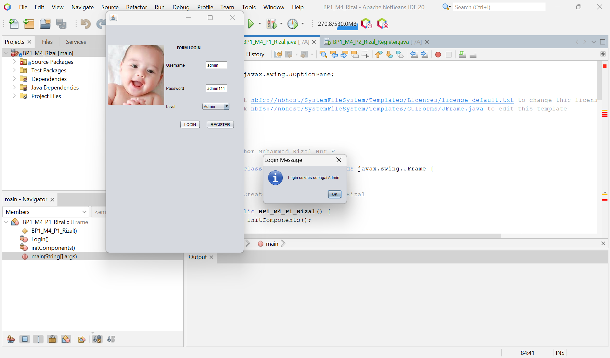
Analisis :
- JComboBox untuk Level Login:
- jComboBox1 digunakan untuk memilih level login. Nilainya adalah:
- "Pilih Level": Default, menunjukkan bahwa level belum dipilih.
- "Admin": Untuk login sebagai admin.
- "User": Untuk login sebagai user.
- Validasi Input:
- Jika username, password, atau level kosong atau tidak dipilih dengan benar, aplikasi akan menampilkan pesan kesalahan yang relevan.
- Logika Login:
- Kombinasi username, password, dan level diperiksa secara spesifik:
- Admin: username = "admin", password = "admin111", dan level = "Admin".
- User: username = "user", password = "user123", dan level = "User".
- Jika kombinasi salah, maka akan muncul pesan "Username, Password, atau Level salah".
- Pesan Informasi:
- Menggunakan JOptionPane untuk menampilkan dialog pesan yang sesuai (sukses/gagal).

- Lengkapi kondisi Register, sehingga memiliki kondisi
- Jika button register pada Form Registrasi di klik, maka Form Registrasi kembali kosong.
- Jika button register pada Form Registrasi di klik, maka akan tampil message "registrasi berhasil".
- Jika button register pada Form Registrasi di klik, maka akan tampil message "registrasi gagal, data harus lengkap" jika ada data yang tidak diisi.
- Tambahkan tombol untuk keluar dari tampilan Form Registrasi.
/*
* Click nbfs://nbhost/SystemFileSystem/Templates/Licenses/license-default.txt to change this license
* Click nbfs://nbhost/SystemFileSystem/Templates/GUIForms/JFrame.java to edit this template
*/

/**
*
* @author Muhammad Rizal Nur F
*/

import javax.swing.*;
import java.awt.*;
import java.awt.event.ActionEvent;
import java.awt.event.ActionListener;

public class BP1_M4_P2_Rizal_Register extends JFrame {

// Komponen UI
private JTextField txtNIM, txtNama;
private JRadioButton rbLaki, rbPerempuan;
private JComboBox<String> cbProdi;
private JCheckBox cbNonton, cbOlahraga, cbDengerinMusik, cbTraveling;
private JTextArea txtAlamat, txtHasil;
private JButton btnRegister, btnKeluar;

public BP1_M4_P2_Rizal_Register() {
// Set title JFrame
setTitle("FORM REGISTER");
setSize(400, 600);
setDefaultCloseOperation(JFrame.EXIT_ON_CLOSE);
setLayout(null);

// Membuat label FORM REGISTER
JLabel lblTitle = new JLabel("FORM REGISTER", SwingConstants.CENTER);
lblTitle.setBounds(100, 10, 200, 30);
lblTitle.setFont(new Font("Arial", Font.BOLD, 16));
add(lblTitle);

// Label dan TextField untuk NIM
JLabel lblNIM = new JLabel("NIM");
lblNIM.setBounds(20, 50, 100, 30);
add(lblNIM);
txtNIM = new JTextField();
txtNIM.setBounds(120, 50, 240, 30);
add(txtNIM);

// Label dan TextField untuk Nama
JLabel lblNama = new JLabel("NAMA");
lblNama.setBounds(20, 90, 100, 30);
add(lblNama);
txtNama = new JTextField();
txtNama.setBounds(120, 90, 240, 30);
add(txtNama);

// Label dan RadioButton untuk Jenis Kelamin
JLabel lblJenisKelamin = new JLabel("JENIS KELAMIN");
lblJenisKelamin.setBounds(20, 130, 100, 30);
add(lblJenisKelamin);
rbLaki = new JRadioButton("LAKI-LAKI");
rbLaki.setBounds(120, 130, 100, 30);
rbPerempuan = new JRadioButton("PEREMPUAN");
rbPerempuan.setBounds(220, 130, 100, 30);

// Grouping RadioButton
ButtonGroup bgJenisKelamin = new ButtonGroup();
bgJenisKelamin.add(rbLaki);
bgJenisKelamin.add(rbPerempuan);
add(rbLaki);
add(rbPerempuan);

// Label dan ComboBox untuk Prodi
JLabel lblProdi = new JLabel("PRODI");
lblProdi.setBounds(20, 170, 100, 30);
add(lblProdi);
String[] prodiList = {"TEKNIK INFORMATIKA", "SISTEM INFORMASI", "DESAIN KOMUNIKASI VISUAL", "MANAJEMEN INFORMATIKA"};
cbProdi = new JComboBox<>(prodiList);
cbProdi.setBounds(120, 170, 240, 30);
add(cbProdi);

// Label dan CheckBox untuk Hobi
JLabel lblHobi = new JLabel("HOBI");
lblHobi.setBounds(20, 210, 100, 30);
add(lblHobi);
cbNonton = new JCheckBox("NONTON");
cbNonton.setBounds(120, 210, 100, 30);
cbDengerinMusik = new JCheckBox("DENGERIN MUSIK");
cbDengerinMusik.setBounds(220, 210, 130, 30);
cbOlahraga = new JCheckBox("OLAHRAGA");
cbOlahraga.setBounds(120, 240, 100, 30);
cbTraveling = new JCheckBox("TRAVELING");
cbTraveling.setBounds(220, 240, 100, 30);
add(cbNonton);
add(cbDengerinMusik);
add(cbOlahraga);
add(cbTraveling);

// Label dan TextArea untuk Alamat
JLabel lblAlamat = new JLabel("ALAMAT");
lblAlamat.setBounds(20, 280, 100, 30);
add(lblAlamat);
txtAlamat = new JTextArea();
txtAlamat.setBounds(120, 280, 240, 60);
add(txtAlamat);

// Button Register
btnRegister = new JButton("REGISTER");
btnRegister.setBounds(120, 360, 100, 30);
add(btnRegister);

// Button Keluar
btnKeluar = new JButton("KELUAR");
btnKeluar.setBounds(240, 360, 100, 30);
add(btnKeluar);

// TextArea untuk menampilkan hasil registrasi
txtHasil = new JTextArea();
txtHasil.setBounds(20, 410, 340, 120);
txtHasil.setEditable(false);
txtHasil.setBorder(BorderFactory.createLineBorder(Color.BLACK));
add(txtHasil);

// Action Listener untuk tombol Register
btnRegister.addActionListener(new ActionListener() {
@Override
public void actionPerformed(ActionEvent e) {
if (isDataLengkap()) {
tampilkanHasil();
JOptionPane.showMessageDialog(null, "Registrasi berhasil!", "Informasi", JOptionPane.INFORMATION_MESSAGE);
clearForm();
} else {
JOptionPane.showMessageDialog(null, "Registrasi gagal, data harus lengkap!", "Error", JOptionPane.ERROR_MESSAGE);
}
}
});

// Action Listener untuk tombol Keluar
btnKeluar.addActionListener(new ActionListener() {
@Override
public void actionPerformed(ActionEvent e) {
System.exit(0);
}
});

// Set JFrame visible
setVisible(true);
}

// Method untuk menampilkan hasil registrasi
private void tampilkanHasil() {
String jenisKelamin = rbLaki.isSelected() ? "LAKI-LAKI" : (rbPerempuan.isSelected() ? "PEREMPUAN" : "TIDAK DIPILIH");
String hobi = "";
if (cbNonton.isSelected()) hobi += "NONTON ";
if (cbOlahraga.isSelected()) hobi += "OLAHRAGA ";
if (cbDengerinMusik.isSelected()) hobi += "DENGERIN MUSIK ";
if (cbTraveling.isSelected()) hobi += "TRAVELING ";

// Menggabungkan hasil registrasi
String hasil = "NIM: " + txtNIM.getText() + "\n" +
"NAMA: " + txtNama.getText() + "\n" +
"JENIS KELAMIN: " + jenisKelamin + "\n" +
"PRODI: " + cbProdi.getSelectedItem() + "\n" +
"HOBI: " + hobi + "\n" +
"ALAMAT: " + txtAlamat.getText();
txtHasil.setText(hasil);
}

// Method untuk mengecek kelengkapan data
private boolean isDataLengkap() {
return !txtNIM.getText().isEmpty() && !txtNama.getText().isEmpty() &&
(rbLaki.isSelected() || rbPerempuan.isSelected()) &&
txtAlamat.getText() != null && !txtAlamat.getText().isEmpty();
}

// Method untuk mengosongkan form
private void clearForm() {
txtNIM.setText("");
txtNama.setText("");
rbLaki.setSelected(false);
rbPerempuan.setSelected(false);
cbProdi.setSelectedIndex(0);
cbNonton.setSelected(false);
cbOlahraga.setSelected(false);
cbDengerinMusik.setSelected(false);
cbTraveling.setSelected(false);
txtAlamat.setText("");
txtHasil.setText("");
}

public static void main(String[] args) {
new BP1_M4_P2_Rizal_Register();
}
}

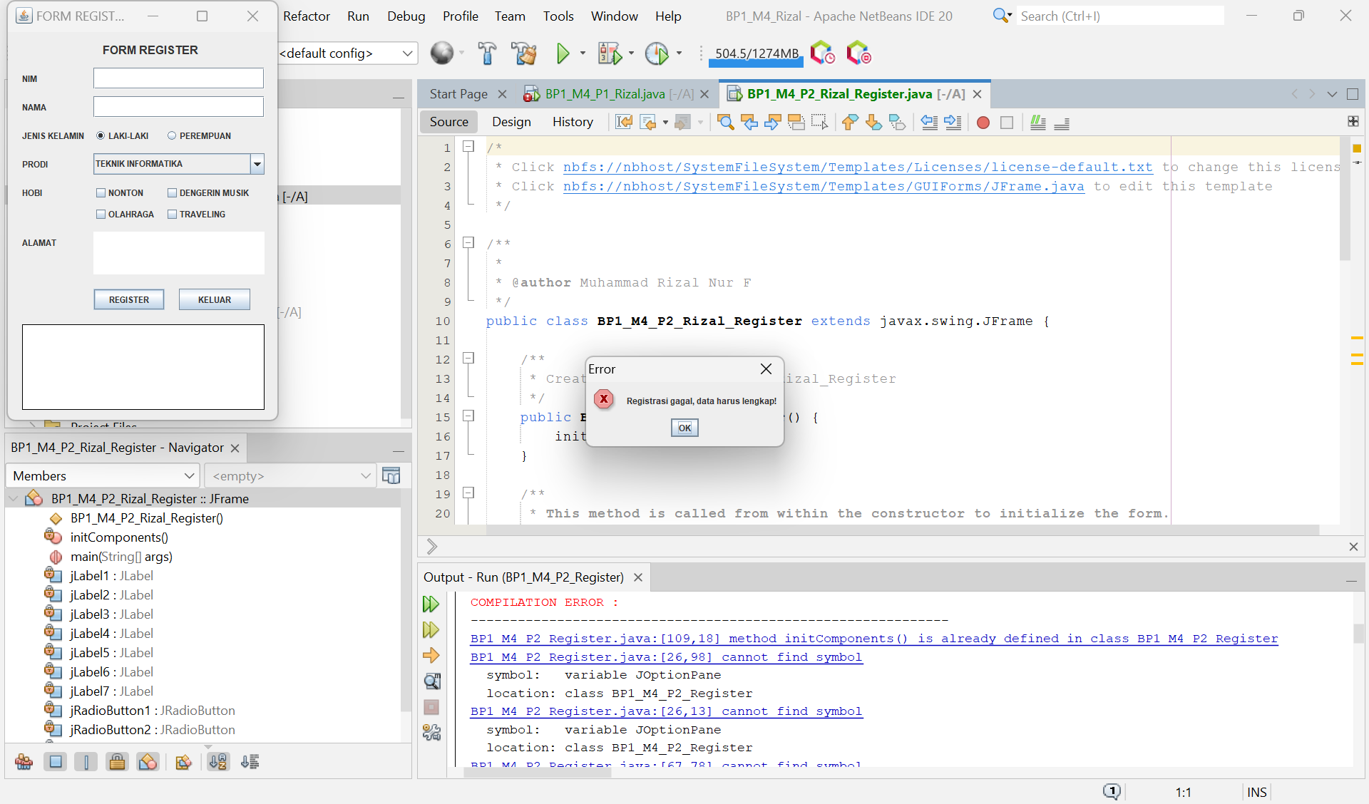
Analisis : Program ini adalah aplikasi registrasi sederhana dengan form yang melibatkan input data pengguna seperti NIM, nama, jenis kelamin, program studi, hobi, dan alamat. Ketika tombol "Register" ditekan, sistem pertama-tama memeriksa kelengkapan data yang dimasukkan. Jika ada data yang kosong atau tidak terisi dengan benar, program akan menampilkan pesan "Registrasi gagal, data harus lengkap". Jika semua data lengkap, maka aplikasi akan menampilkan pesan sukses "Registrasi berhasil" dan data yang dimasukkan akan ditampilkan di area teks, lalu form akan direset ke keadaan semula.
Tugas
- Lengkapi / koneksikan pada Form Login jika di klik maka akan tampil Form Register.
- Tambahkan data yang harus diisi pada Form Register (Kelas, Angkatan, DPA, Semester).
- Buat Form Data Nilai Mahasiswa.
- Jika Register gagal, maka tampilan akan kembali ke Form Login.
- Jika Register berhasil, maka akan tampil Form Data Nilai Mahasiswa.
/*
* Click nbfs://nbhost/SystemFileSystem/Templates/Licenses/license-default.txt to change this license
* Click nbfs://nbhost/SystemFileSystem/Templates/GUIForms/JFrame.java to edit this template
*/

import javax.swing.JOptionPane;
/**
*
* @author Muhammad Rizal Nur F
*/
public class BP1_M4_P1_Rizal extends javax.swing.JFrame {

public BP1_M4_P1_Rizal() {
initComponents(); // Inisialisasi komponen yang ada di desain GUI
}

@SuppressWarnings("unchecked")
private void initComponents() {

jLabel1 = new javax.swing.JLabel();
jLabel2 = new javax.swing.JLabel();
txtUsername = new javax.swing.JTextField();
txtPassword = new javax.swing.JPasswordField();
btnLogin = new javax.swing.JButton();
btnRegister = new javax.swing.JButton();
jLabelImage = new javax.swing.JLabel(); // Label untuk gambar
jLabel3 = new javax.swing.JLabel(); // Label untuk level
comboLevel = new javax.swing.JComboBox<>(); // JComboBox untuk level
txtAreaOutput = new javax.swing.JTextArea(); // JTextArea untuk menampilkan hasil inputan

setDefaultCloseOperation(javax.swing.WindowConstants.EXIT_ON_CLOSE);

jLabel1.setText("Username:");
jLabel2.setText("Password:");
jLabel3.setText("Level:");

// Menambahkan pilihan level
comboLevel.setModel(new javax.swing.DefaultComboBoxModel<>(new String[] { "Admin", "User " }));

btnLogin.setText("Login");
btnLogin.addActionListener(evt -> btnLoginActionPerformed(evt));

btnRegister.setText("Register");
btnRegister.addActionListener(evt -> btnRegisterActionPerformed(evt));

// Menambahkan gambar bayi
try {
jLabelImage.setIcon(new javax.swing.ImageIcon(getClass().getResource("/bayi.jpg"))); // pastikan gambar ada di folder yang tepat
} catch (NullPointerException e) {
JOptionPane.showMessageDialog(this, "Gambar tidak ditemukan!", "Error", JOptionPane.ERROR_MESSAGE);
}

// Mengatur JTextArea
txtAreaOutput.setEditable(false); // Tidak bisa diedit oleh pengguna
txtAreaOutput.setRows(5); // Jumlah baris
txtAreaOutput.setColumns(20); // Jumlah kolom

javax.swing.GroupLayout layout = new javax.swing.GroupLayout(getContentPane());
getContentPane().setLayout(layout);
layout.setHorizontalGroup(
layout.createParallelGroup(javax.swing.GroupLayout.Alignment.LEADING)
.addGroup(layout.createSequentialGroup()
.addGap(30, 30, 30)
.addComponent(jLabelImage) // Menampilkan gambar bayi di kiri
.addGap(18, 18, 18)
.addGroup(layout.createParallelGroup(javax.swing.GroupLayout.Alignment.LEADING, false)
.addGroup(layout.createSequentialGroup()
.addComponent(jLabel1)
.addPreferredGap(javax.swing.LayoutStyle.ComponentPlacement.RELATED)
.addComponent(txtUsername, javax.swing.GroupLayout.PREFERRED_SIZE, 150, javax.swing.GroupLayout.PREFERRED_SIZE))
.addGroup(layout.createSequentialGroup()
.addComponent(jLabel2)
.addPreferredGap(javax.swing.LayoutStyle.ComponentPlacement.RELATED)
.addComponent(txtPassword))
.addGroup(layout.createSequentialGroup()
.addComponent(jLabel3)
.addPreferredGap(javax.swing.LayoutStyle.ComponentPlacement.RELATED)
.addComponent(comboLevel, javax.swing.GroupLayout.PREFERRED_SIZE, 150, javax.swing.GroupLayout.PREFERRED_SIZE))
.addGroup(layout.createSequentialGroup()
.addComponent(btnLogin, javax.swing.GroupLayout.PREFERRED_SIZE, 75, javax.swing.GroupLayout.PREFERRED_SIZE)
.addPreferredGap(javax.swing.LayoutStyle.ComponentPlacement.RELATED)
.addComponent(btnRegister, javax.swing.GroupLayout.DEFAULT_SIZE, javax.swing.GroupLayout.DEFAULT_SIZE, Short.MAX_VALUE)))
.addContainerGap(30, Short.MAX_VALUE))
.addGroup(layout.createSequentialGroup()
.addGap(30, 30, 30)
.addComponent(txtAreaOutput) // Menampilkan JTextArea di bawah
.addContainerGap(30, Short.MAX_VALUE))
);
layout.setVerticalGroup(
layout.createSequentialGroup()
.addGap(30, 30, 30)
.addGroup(layout.createParallelGroup(javax.swing.GroupLayout.Alignment.LEADING)
.addComponent(jLabelImage) // Gambar bayi di kiri
.addGroup(layout.createSequentialGroup()
.addGroup(layout.createParallelGroup(javax.swing.GroupLayout.Alignment.BASELINE)
.addComponent(jLabel1)
.addComponent(txtUsername, javax.swing.GroupLayout.PREFERRED_SIZE, javax.swing.GroupLayout.DEFAULT_SIZE, javax.swing.GroupLayout.PREFERRED_SIZE))
.addPreferredGap(javax.swing.LayoutStyle.ComponentPlacement.RELATED)
.addGroup(layout.createParallelGroup(javax.swing.GroupLayout.Alignment.BASELINE)
.addComponent(jLabel2)
.addComponent(txtPassword, javax.swing.GroupLayout.PREFERRED_SIZE, javax.swing.GroupLayout.DEFAULT_SIZE, javax.swing.GroupLayout.PREFERRED_SIZE))
.addPreferredGap(javax.swing.LayoutStyle.ComponentPlacement.RELATED)
.addGroup(layout.createParallelGroup(javax.swing.GroupLayout.Alignment.BASELINE)
.addComponent(jLabel3)
.addComponent(comboLevel, javax.swing.GroupLayout.PREFERRED_SIZE, javax.swing.GroupLayout.DEFAULT_SIZE, javax.swing.GroupLayout.PREFERRED_SIZE))
.addPreferredGap(javax.swing.LayoutStyle.ComponentPlacement.RELATED)
.addGroup(layout.createParallelGroup(javax.swing.GroupLayout.Alignment.BASELINE)
.addComponent(btnLogin)
.addComponent(btnRegister))))
.addPreferredGap(javax.swing.LayoutStyle.ComponentPlacement.RELATED)
.addComponent(txtAreaOutput, javax.swing.GroupLayout.PREFERRED_SIZE, 100, javax.swing.GroupLayout.PREFERRED_SIZE) // Ukuran JTextArea
.addContainerGap(30, Short.MAX_VALUE)
);

pack();
}

private void btnLoginActionPerformed(java.awt.event.ActionEvent evt) {
// Validasi login
String username = txtUsername.getText().trim();
String password = new String(txtPassword.getPassword()).trim();
String level = (String) comboLevel.getSelectedItem(); // Mendapatkan level yang dipilih

if (username.isEmpty() || password.isEmpty()) {
JOptionPane.showMessageDialog(this, "Username dan Password tidak boleh kosong!", "Error", JOptionPane.ERROR_MESSAGE);
return;
}

// Validasi berdasarkan level
if (level.equals("Admin") && username.equals("admin") && password.equals("admin123")) {
JOptionPane.showMessageDialog(this, "Login Berhasil sebagai Admin!");
// Tampilkan hasil inputan di JTextArea
txtAreaOutput.setText("Username: " + username + "\nPassword: " + password + "\nLevel: " + level);
// Pindah ke Form Data Nilai Mahasiswa jika login berhasil
new FormDataNilaiMahasiswa().setVisible(true);
this.dispose(); // Menutup form login setelah berpindah
} else if (level.equals("User ") && username.equals("user") && password.equals("user123")) {
JOptionPane.showMessageDialog(this, "Login Berhasil sebagai User!");
// Tampilkan hasil inputan di JTextArea
txtAreaOutput.setText("Username: " + username + "\nPassword: " + password + "\nLevel: " + level);
// Pindah ke Form User jika login berhasil
new FormUser ().setVisible(true);
this.dispose(); // Menutup form login setelah berpindah
} else {
JOptionPane.showMessageDialog(this, "Username atau Password salah!", "Error", JOptionPane.ERROR_MESSAGE);
}
}

private void btnRegisterActionPerformed(java.awt.event.ActionEvent evt) {
// Pindah ke Form Register
new BP1_M4_P2_Rizal_Register().setVisible(true);
this.dispose(); // Tutup form login setelah berpindah
}

public static void main(String args[]) {
/* Set the Nimbus look and feel */
try {
for (javax.swing.UIManager.LookAndFeelInfo info : javax.swing.UIManager.getInstalledLookAndFeels()) {
if ("Nimbus".equals(info.getName())) {
javax.swing.UIManager.setLookAndFeel(info.getClassName());
break;
}
}
} catch (ClassNotFoundException | InstantiationException | IllegalAccessException | javax.swing.UnsupportedLookAndFeelException ex) {
java.util.logging.Logger.getLogger(BP1_M4_P1_Rizal.class.getName()).log(java.util.logging.Level.SEVERE, null, ex);
}

/* Create and display the form */
java.awt.EventQueue.invokeLater(() -> new BP1_M4_P1_Rizal().setVisible(true));
}

// Variables declaration - do not modify
private javax.swing.JButton btnLogin;
private javax.swing.JButton btnRegister;
private javax.swing.JLabel jLabel1;
private javax.swing.JLabel jLabel2;
private javax.swing.JLabel jLabel3; // Label untuk level
private javax.swing.JTextField txtUsername;
private javax.swing.JPasswordField txtPassword;
private javax.swing.JLabel jLabelImage; // Label untuk gambar bayi
private javax.swing.JComboBox<String> combo Level; // JComboBox untuk level
private javax.swing.JTextArea txtAreaOutput; // JTextArea untuk menampilkan hasil inputan
// End of variables declaration
}

/*
* Click nbfs://nbhost/SystemFileSystem/Templates/Licenses/license-default.txt to change this license
* Click nbfs://nbhost/SystemFileSystem/Templates/GUIForms/JFrame.java to edit this template
*/

import javax.swing.*;
import java.awt.*;
import java.awt.event.ActionEvent;
import java.awt.event.ActionListener;

/**
*
* @author Muhammad Rizal Nur F
*/
public class BP1_M4_P2_Rizal_Register extends JFrame {
private JTextField txtNIM, txtNama, txtKelas, txtAngkatan, txtDPA, txtSemester;
private JRadioButton rbLaki, rbPerempuan;
private JComboBox<String> cbProdi;
private JCheckBox cbNonton, cbOlahraga, cbDengerinMusik, cbTraveling;
private JTextArea txtAlamat, txtHasil; // Declare txtHasil for results
private JButton btnRegister, btnKeluar;

public BP1_M4_P2_Rizal_Register() {
// Set title JFrame
setTitle("FORM REGISTER");
setSize(400, 800); // Increase size to accommodate new fields
setDefaultCloseOperation(JFrame.EXIT_ON_CLOSE);
setLayout(null);

// Title
JLabel lblTitle = new JLabel("FORM REGISTER", SwingConstants.CENTER);
lblTitle.setBounds(100, 10, 200, 30);
lblTitle.setFont(new Font("Arial", Font.BOLD, 16));
add(lblTitle);

// NIM
JLabel lblNIM = new JLabel("NIM");
lblNIM.setBounds(20, 50, 100, 30);
add(lblNIM);
txtNIM = new JTextField();
txtNIM.setBounds(120, 50, 240, 30);
add(txtNIM);

// Nama
JLabel lblNama = new JLabel("NAMA");
lblNama.setBounds(20, 90, 100, 30);
add(lblNama);
txtNama = new JTextField();
txtNama.setBounds(120, 90, 240, 30);
add(txtNama);

// Jenis Kelamin
JLabel lblJenisKelamin = new JLabel("JENIS KELAMIN");
lblJenisKelamin.setBounds(20, 130, 100, 30);
add(lblJenisKelamin);

rbLaki = new JRadioButton("Laki-laki");
rbLaki.setBounds(120, 130, 100, 30);
add(rbLaki);

rbPerempuan = new JRadioButton("Perempuan");
rbPerempuan.setBounds(230, 130, 100, 30);
add(rbPerempuan);

ButtonGroup genderGroup = new ButtonGroup();
genderGroup.add(rbLaki);
genderGroup.add(rbPerempuan);

// Prodi
JLabel lblProdi = new JLabel("PRODI");
lblProdi.setBounds(20, 170, 100, 30);
add(lblProdi);
String[] prodiOptions = {"Teknik Informatika", "Sistem Informasi", "Manajemen"};
cbProdi = new JComboBox<>(prodiOptions);
cbProdi.setBounds(120, 170, 240, 30);
add(cbProdi);

// Hobi
JLabel lblHobi = new JLabel("HOBI");
lblHobi.setBounds(20, 210, 100, 30);
add(lblHobi);

cbNonton = new JCheckBox("Nonton");
cbNonton.setBounds(120, 210, 100, 30);
add(cbNonton);

cbOlahraga = new JCheckBox("Dedengerin Musik");
cbOlahraga.setBounds(230, 210, 100, 30);
add(cbOlahraga);

cbDengerinMusik = new JCheckBox("Olahraga");
cbDengerinMusik.setBounds(120, 240, 150, 30);
add(cbDengerinMusik);

cbTraveling = new JCheckBox("Traveling");
cbTraveling.setBounds(230, 240, 100, 30);
add(cbTraveling);

// Alamat
JLabel lblAlamat = new JLabel("ALAMAT");
lblAlamat.setBounds(20, 280, 100, 30);
add(lblAlamat);
txtAlamat = new JTextArea();
txtAlamat.setBounds(120, 280, 240, 50);
add(txtAlamat);

// Kelas
JLabel lblKelas = new JLabel("KELAS");
lblKelas.setBounds(20, 340, 100, 30);
add(lblKelas);
txtKelas = new JTextField();
txtKelas.setBounds(120, 340, 240, 30);
add(txtKelas);

// Angkatan
JLabel lblAngkatan = new JLabel("ANGKATAN");
lblAngkatan.setBounds(20, 380, 100, 30);
add(lblAngkatan);
txtAngkatan = new JTextField();
txtAngkatan.setBounds(120, 380, 240, 30);
add(txtAngkatan);

// DPA
JLabel lblDPA = new JLabel("DPA");
lblDPA.setBounds(20, 420, 100, 30);
add(lblDPA);
txtDPA = new JTextField();
txtDPA.setBounds(120, 420, 240, 30);
add(txtDPA);

// Semester
JLabel lblSemester = new JLabel("SEMESTER");
lblSemester.setBounds(20, 460, 100, 30);
add(lblSemester);
txtSemester = new JTextField();
txtSemester.setBounds(120, 460, 240, 30);
add(txtSemester);

// Register and Exit Buttons
btnRegister = new JButton("Register");
btnRegister.setBounds(120, 500, 100, 30);
add(btnRegister);

btnKeluar = new JButton("Keluar");
btnKeluar.setBounds(230, 500, 100, 30);
add(btnKeluar);

// Result TextArea
txtHasil = new JTextArea();
txtHasil.setBounds(20, 540, 340, 150);
txtHasil.setEditable(false); // Make it non-editable
add(txtHasil);

// Action Listener for Register
btnRegister.addActionListener(new ActionListener() {
@Override
public void actionPerformed(ActionEvent e) {
if (isDataLengkap()) {
tampilkanHasil();
JOptionPane.showMessageDialog(null, "Registrasi berhasil!", "Informasi", JOptionPane.INFORMATION_MESSAGE);
new FormDataNilaiMahasiswa(); // Show the next form
dispose(); // Close register form
} else {
JOptionPane.showMessageDialog(null, "Registrasi gagal, data harus lengkap!", "Error", JOptionPane.ERROR_MESSAGE);
new BP1_M4_P1_Rizal(); // Show login form again
dispose(); // Close register form
}
}
});

// Action Listener for Exit
btnKeluar.addActionListener(new ActionListener() {
@Override
public void actionPerformed(ActionEvent e) {
System.exit(0);
}
});

setVisible(true);
}

// Method to check if data is complete
private boolean isDataLengkap() {
// Check if all fields are filled
return !txtNIM.getText().isEmpty() && !txtNama.getText().isEmpty() &&
!txtKelas.getText().isEmpty() && !txtAngkatan.getText().isEmpty() &&
!txtDPA.getText().isEmpty() && !txtSemester.getText().isEmpty() &&
(rbLaki.isSelected() || rbPerempuan.isSelected()) && cbProdi.getSelectedIndex() != -1;
}

// Method to display the results in a TextArea
private void tampilkanHasil() {
String hasil = "NIM: " + txtNIM.getText() + "\n";
hasil += "Nama: " + txtNama.getText() + "\n";
hasil += "Jenis Kelamin: " + (rbLaki.isSelected() ? "Laki-laki" : "Perempuan") + "\n";
hasil += "Prodi: " + cbProdi.getSelectedItem() + "\n";
hasil += "Hobi: " + (cbNonton.isSelected() ? "Nonton, " : "") +
(cbOlahraga.isSelected() ? "Olahraga, " : "") +
(cbDengerinMusik.isSelected() ? "Dengerin Musik, " : "") +
(cbTraveling.isSelected() ? "Traveling" : "") + "\n";
hasil += "Alamat: " + txtAlamat.getText() + "\n";
hasil += "Kelas: " + txtKelas.getText() + "\n";
hasil += "Angkatan: " + txtAngkatan.getText() + "\n";
hasil += "DPA: " + txtDPA.getText() + "\n";
hasil += "Semester: " + txtSemester.getText() + "\n";

txtHasil.setText(hasil); // Set the result to the JTextArea
}

public static void main(String[] args) {
// Create and display the register form
new BP1_M4_P2_Rizal_Register();
}
}

/*
* Click nbfs://nbhost/SystemFileSystem/Templates/Licenses/license-default.txt to change this license
* Click nbfs://nbhost/SystemFileSystem/Templates/GUIForms/JFrame.java to edit this template
*/

import javax.swing.*;
import java.awt.event.*;

public class FormDataNilaiMahasiswa extends JFrame {
private JTextField txtNIM, txtNama;
private JTextArea txtNilai;
private JButton btnSimpan;

public FormDataNilaiMahasiswa() {
setTitle("Data Nilai Mahasiswa");
setSize(400, 300);
setDefaultCloseOperation(JFrame.EXIT_ON_CLOSE);
setLayout(null);

JLabel lblNIM = new JLabel("NIM");
lblNIM.setBounds(20, 30, 100, 30);
add(lblNIM);
txtNIM = new JTextField();
txtNIM.setBounds(120, 30, 240, 30);
add(txtNIM);

JLabel lblNama = new JLabel("Nama");
lblNama.setBounds(20, 70, 100, 30);
add(lblNama);
txtNama = new JTextField();
txtNama.setBounds(120, 70, 240, 30);
add(txtNama);

JLabel lblNilai = new JLabel("Nilai");
lblNilai.setBounds(20, 110, 100, 30);
add(lblNilai);
txtNilai = new JTextArea();
txtNilai.setBounds(120, 110, 240, 100);
add(txtNilai);

btnSimpan = new JButton("Simpan");
btnSimpan.setBounds(150, 220, 100, 30);
add(btnSimpan);

btnSimpan.addActionListener(new ActionListener() {
@Override
public void actionPerformed(ActionEvent e) {
JOptionPane.showMessageDialog(null, "Data Nilai Tersimpan!", "Informasi", JOptionPane.INFORMATION_MESSAGE);
}
});

setVisible(true);
}
}

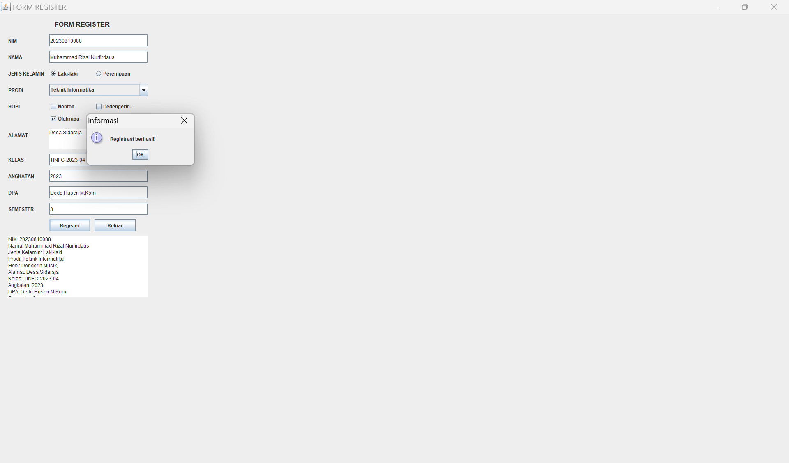
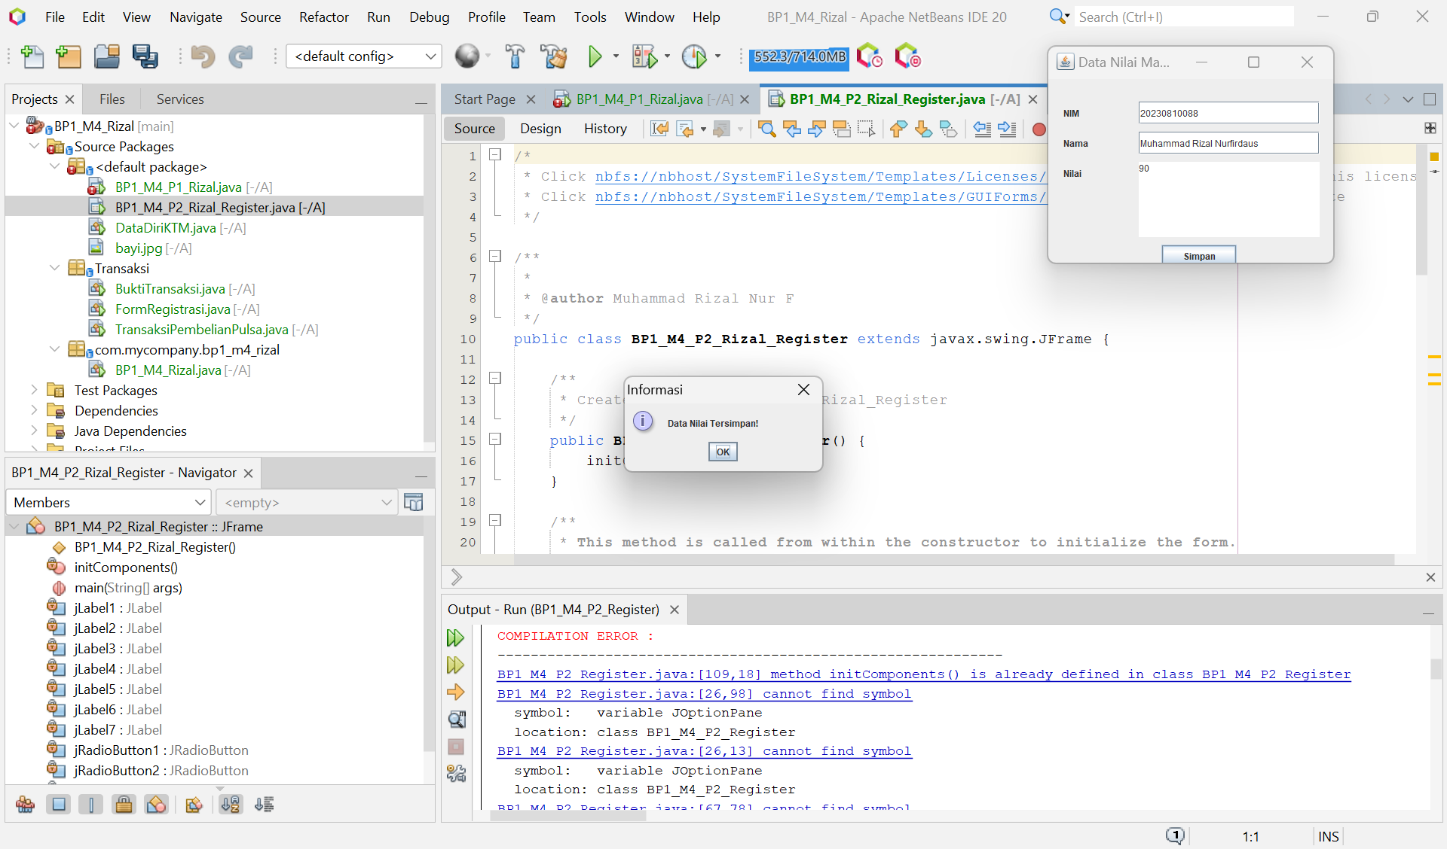
Analisis :
- Form Login: Memungkinkan pengguna untuk login, dan setelah login berhasil, form login akan menutup dan form registrasi akan muncul.
- Form Register: Menambahkan kolom untuk Kelas, Angkatan, DPA, dan Semester. Jika registrasi berhasil, form nilai mahasiswa akan muncul. Jika gagal, kembali ke form login.
- Form Data Nilai Mahasiswa: Menyediakan input untuk NIM, Nama, dan Nilai, serta tombol untuk menyimpan data.
Dengan tambahan ini, Aplikasi pendaftaran dengan validasi dan alur yang lebih jelas, serta tampilan yang lebih terstruktur.

Tugas Tambahan
  - Buatlah sebuah aplikasi yang didalamnya terdapat hirarki menu sebagai berikut
Menu: Bangun Datar
Segitiga (Alt+s)
Persegi (Alt+p)
Lingkaran (Alt+l)

Menu Bangun Ruang
Kubus (Alt+k)
Balok (Alt+b)
Tabung (Alt+t)

Ketika sub menu diklik (atau menekan shortcut) maka akan menampilkan form sesuai dengan sub menu.

Tambahkan kedalam laporan praktikum screenshoot hasil dan penjelasan singkat kode nya.
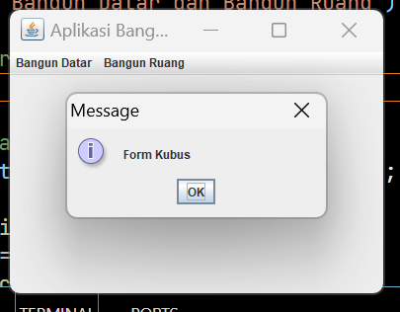
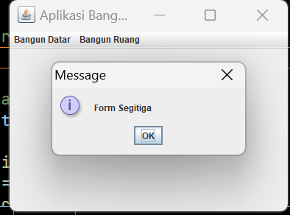

Script Code:
package BP1_M4_Rizal;

import javax.swing.*;
import java.awt.event.ActionEvent;
import java.awt.event.ActionListener;

public class MenuAplikasi extends JFrame {
public MenuAplikasi() {
// Set judul jendela
setTitle("Aplikasi Bangun Datar dan Bangun Ruang");

// Membuat menu bar
JMenuBar menuBar = new JMenuBar();

// Menu Bangun Datar
JMenu menuBangunDatar = new JMenu("Bangun Datar");
JMenuItem segitiga = new JMenuItem("Segitiga");
segitiga.setMnemonic('S'); // Alt + S
JMenuItem persegi = new JMenuItem("Persegi");
persegi.setMnemonic('P'); // Alt + P
JMenuItem lingkaran = new JMenuItem("Lingkaran");
lingkaran.setMnemonic('L'); // Alt + L
menuBangunDatar.add(segitiga);
menuBangunDatar.add(persegi);
menuBangunDatar.add(lingkaran);

// Menu Bangun Ruang
JMenu menuBangunRuang = new JMenu("Bangun Ruang");
JMenuItem kubus = new JMenuItem("Kubus");
kubus.setMnemonic('K'); // Alt + K
JMenuItem balok = new JMenuItem("Balok");
balok.setMnemonic('B'); // Alt + B
JMenuItem tabung = new JMenuItem("Tabung");
tabung.setMnemonic('T'); // Alt + T
menuBangunRuang.add(kubus);
menuBangunRuang.add(balok);
menuBangunRuang.add(tabung);

// Tambahkan menu ke menu bar
menuBar.add(menuBangunDatar);
menuBar.add(menuBangunRuang);
setJMenuBar(menuBar);

// Menambahkan action listener untuk setiap item menu
segitiga.addActionListener(e -> JOptionPane.showMessageDialog(this, "Form Segitiga"));
persegi.addActionListener(e -> JOptionPane.showMessageDialog(this, "Form Persegi"));
lingkaran.addActionListener(e -> JOptionPane.showMessageDialog(this, "Form Lingkaran"));
kubus.addActionListener(e -> JOptionPane.showMessageDialog(this, "Form Kubus"));
balok.addActionListener(e -> JOptionPane.showMessageDialog(this, "Form Balok"));
tabung.addActionListener(e -> JOptionPane.showMessageDialog(this, "Form Tabung"));

// Pengaturan jendela
setSize(400, 300);
setDefaultCloseOperation(JFrame.EXIT_ON_CLOSE);
setLocationRelativeTo(null); // Center the window
}

public static void main(String[] args) {
SwingUtilities.invokeLater(() -> {
MenuAplikasi frame = new MenuAplikasi();
frame.setVisible(true);
});
}
}

Penjelasan Singkat
Membuat Menu: Program ini menggunakan JMenuBar untuk membuat menu bar dengan dua menu utama: "Bangun Datar" dan "Bangun Ruang".
Sub Menu dan Shortcut: Setiap submenu (misalnya, Segitiga, Persegi, Lingkaran, Kubus, Balok, Tabung) ditambahkan ke menu utama dan diberikan shortcut menggunakan setMnemonic.
ActionListener: Setiap submenu memiliki ActionListener yang akan menampilkan dialog (menggunakan JOptionPane) saat submenu diklik atau shortcut ditekan. Dialog tersebut berfungsi sebagai form sederhana yang sesuai dengan submenu yang dipilih.
Pengaturan Jendela: Ukuran jendela ditentukan dengan setSize, dan jendela ditampilkan di tengah layar dengan setLocationRelativeTo(null).
Program ini dapat dijalankan di IDE Java seperti NetBeans atau IntelliJ IDEA untuk melihat hasil dan mengambil screenshot sesuai instruksi.

